**Sales Invoice generator**

**Name: Fady Raoof**

**Email: fady.raoof@msa.edu.eg**

**Screen shots of run**

1-First enter id then enter date and should be in specific pattern if does not match the pattern will not add the data input and ask user to wright the date in right pattern

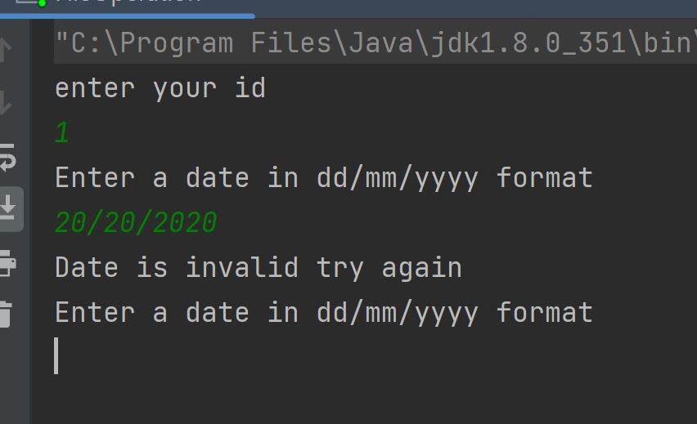

2- Second after take input from user like item name and price and count the program ask if he want to continue to add new items or not if he wright y or inn capital wise Y he will add new items

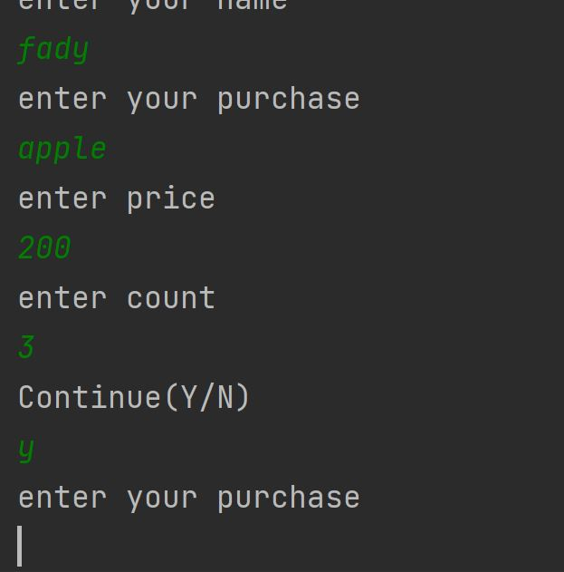

3- Third when user enter the price it shouldn’t be negative number and the system ask him to enter the price in positive way

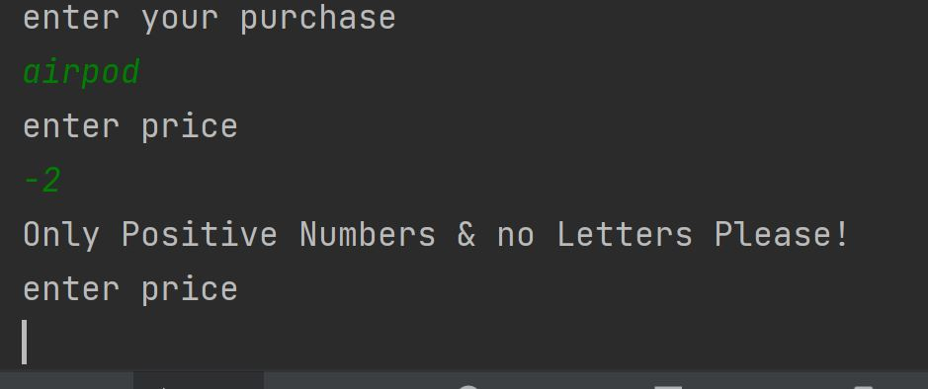

4- Fourth and final if he wright n or N the system save his data and show him all his purchases with full details as it shown below in the screen shot every single item with his total price and after that show the total price of his invoice

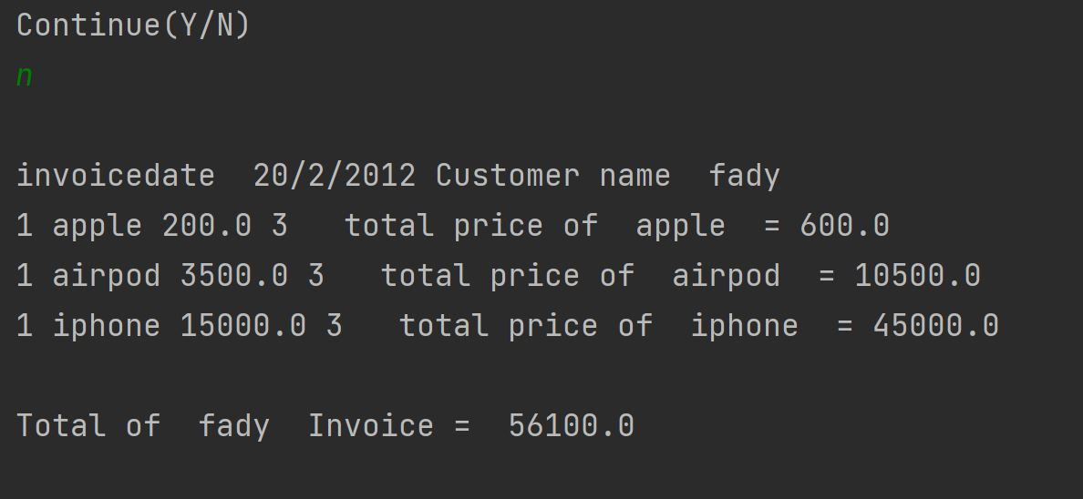

Screen shots of csv files after the user add his data

Invoice Header csv file

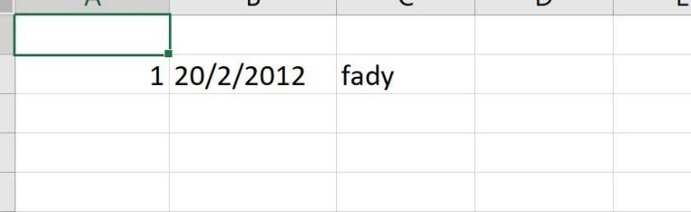

Invoice Line csv file